Course: Web Application Development
Lab Instructor: Dr.Nguyen Van Sinh
Email: nvsinh@hcmiu.edu.vn

Lab 7 - XML

Content:
- XML
  - Defining XML with DTD
  - Processing XML with DOM and SAX
  - Transforming XML with XSLT
- Practices Exercises
Refer from Session 8: XML and Chapter 23 of the Textbook: Core Web Programming, Second Edition.

Duration: 3 hours

Part 1: Defining XML with DTD
- What is XML?
  - XML (eXtensible Markup Language) is a meta-language that describes the content of the document (self-describing meta data). The structure of XML document is defined by DTD or XML Schema.
  - An XML document can be well-formed if it follows basic syntax rules.
  - An XML document is valid if its structure matches its Document Type Definition (DTD) or its XML Schema.
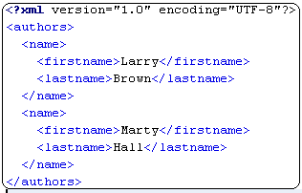
Example: authors.xml

- What is DTD?
  - DTD (Document Type Definition) defines the grammar/structure of document.
  - DTD is not in XML format. It is defined in a DTD file.
  - Learn more about DTD in Chapter 6, XML How to Program.
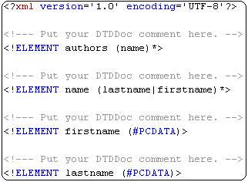
Example: authors.dtd

Implement XML and generate DTD on NetBeans Environment: right click on your project and create new XML file:

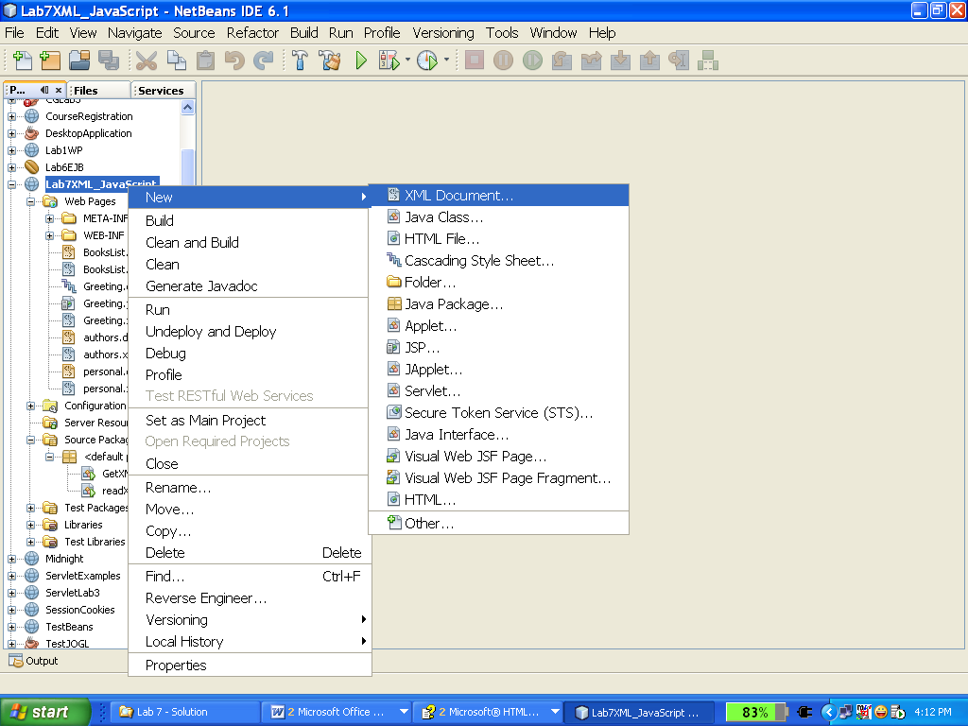
After you have XML file, right click on the XML editor -> Generate DTD:
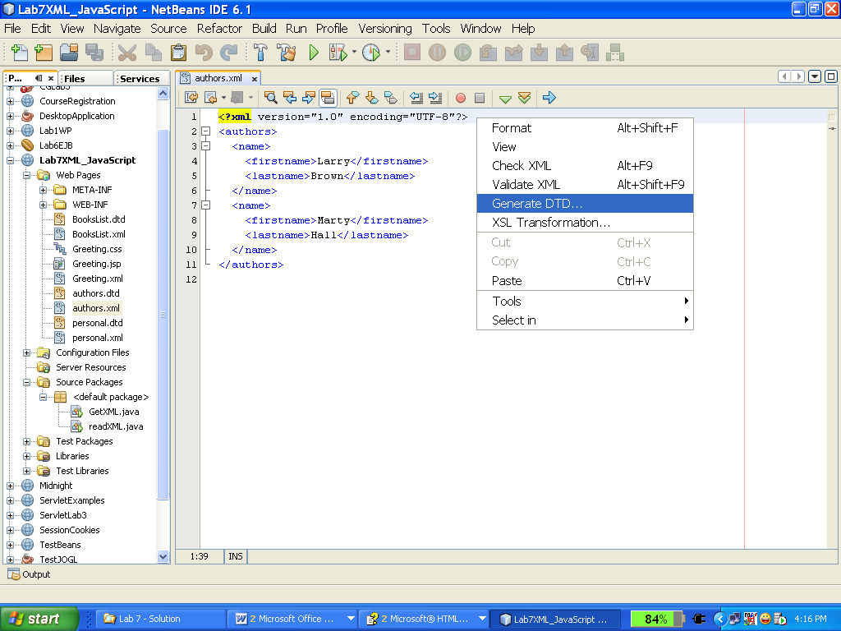

Exercise 1: Create XML and DTD to store the following books data:

ISBN-10 | Title | Author | Publisher | Publication date | Price ($)
0470114878 | Beginning XML, 4th Edition (Programmer to Programmer) | David Hunter, Jeff Rafter, Joe Fawcett, and Eric van Dist | Wrox | May 21, 2007 | 26.39
0596007647 | XML in a Nutshell, Third Edition | Elliotte Rusty Harold and W. Scott Means | O'Reilly Media, Inc. | September 2004 | 26.37
0596004206 | Learning XML, Second Edition | Erik Ray | O'Reilly Media, Inc. | September 22, 2003 | 26.37
0130655678 | Definitive XML Schema (The Charles F. Goldfarb Definitive XML Series) | Priscilla Walmsley | Prentice Hall PTR | December 17, 2001 | 33.38

Hint: there are two files (book.xml and book.dtd)

Part 2: Processing XML with DOM and SAX (refer chapter 23: core Web Programming)
- Document Object Model (DOM)
  - The Document Object Model, DOM for short, is an abstract data structure that represents XML documents as trees made up of nodes stored in memory.
  - The DOM is a standard issued by the W3C. This specification is unrelated to any one programming languages, therefore it is not designed for use with Java specifically. Instead, various bindings of the DOM specification exist for the various programming languages including Java, JavaScript, C++, Python, and Perl.
  - The Xerces Java Parser 1.4.4 supports the XML 1.0 recommendation and contains advanced parser functionality, such as support for the W3C's XML Schema recommendation version 1.0, DOM Level 2 version 1.0, and SAX Version 2, in addition to supporting the industry-standard DOM Level 1 and SAX version 1 APIs.
  - Steps for DOM Parsing:
    - Create a JAXP document builder.
    - Invoke the parser to create a Document representing an XML document.
    - Obtain the root node of the tree
    - Examine and/or modify properties of the node and its children

The following figure is the DOM Model representation of the previous XML file.
<?xml version="1.0" encoding="UTF-8"?>
<!DOCTYPE HOUSE [
<!ENTITY newroom "project room">
]>
<HOUSE>
<UPSTAIRS sqfeet="200">
<ROOM>bedroom</ROOM>
</UPSTAIRS>
<?color blue?>
<DOWNSTAIRS sqfeet="900">
<ROOM>bathroom</ROOM>
<ROOM>kitchen</ROOM>
<ROOM>living <![CDATA[ room ]]></ROOM>
<ROOM>&newroom;</ROOM>
</DOWNSTAIRS>
</HOUSE>
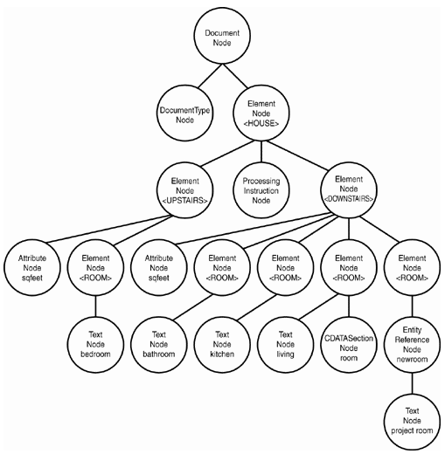
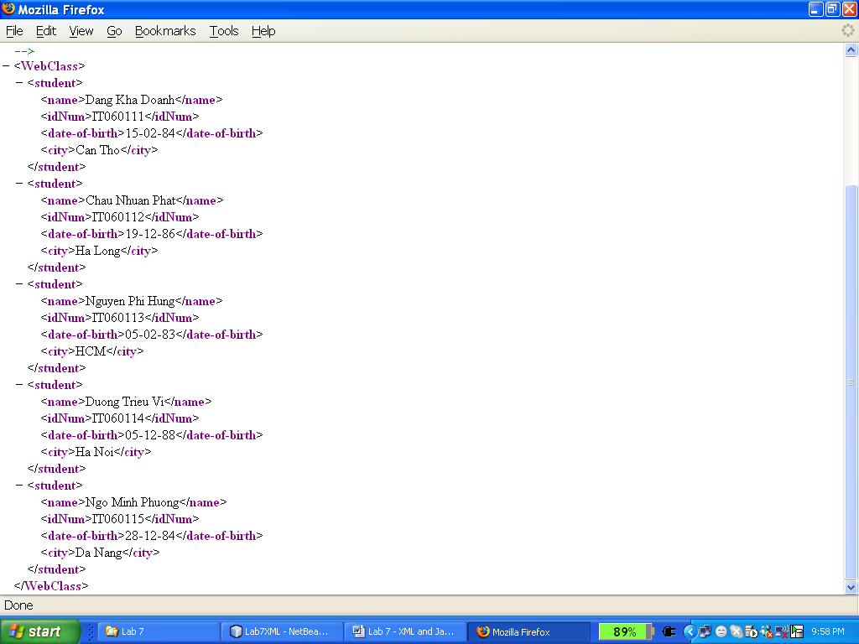 | Exercise 2: Create an XML file “WebClass.xml” as below, then create a JSP file “parsingxml.jsp” to get the content of the WebClass.xml.  Copy the following source:
<%@page contentType="text/html" pageEncoding="UTF-8"%>
<!DOCTYPE HTML PUBLIC "-//W3C//DTD HTML 4.01 Transitional//EN"
"http://www.w3.org/TR/html4/loose.dtd">
<%@page import="org.w3c.dom.*, javax.xml.parsers.*" %>
<%
DocumentBuilderFactory docFactory = DocumentBuilderFactory.newInstance();
DocumentBuilder docBuilder = docFactory.newDocumentBuilder();
Document doc = docBuilder.parse("src//WebClass.xml");
%>
<%!
public boolean isTextNode(Node n){
return n.getNodeName().equals("#text");
}
%>
<html>
<head><title>Parsing of xml using DOM Parser</title></head>
<body>
<h2><font color='red'>Student of Web Class</font></h2>
<table border="2">
<tr>
<th>Name of Student</th>
<th>ID Number</th>
<th>Date of Birth</th>
<th>City</th>
</tr>
<%
Element element = doc.getDocumentElement();
NodeList personNodes = element.getChildNodes();
for (int i=0; i<personNodes.getLength(); i++){
Node stu = personNodes.item(i);
if (isTextNode(stu))
continue;
NodeList NameDOBCity = stu.getChildNodes();
%>
<tr>
<%
for (int j=0; j<NameDOBCity.getLength(); j++ ){
Node node = NameDOBCity.item(j);
if ( isTextNode(node))
continue;
%>
<td><%= node.getFirstChild().getNodeValue() %></td>
<%}%>
</tr>
<%}%>
</table>
</body>
</html>

This is the result on browser:

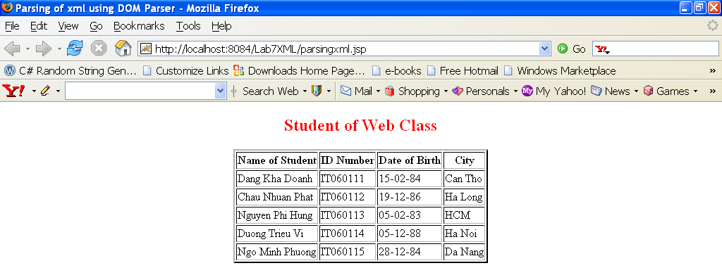

Exercise 3: The same result as Exercise 2, but we use Servlet to parse WebClass.xml
Hint: Create a Servlet “DOMServlet.java”, copy the source code below to test:
protected void processRequest(HttpServletRequest request, HttpServletResponse response)
throws ServletException, IOException {
response.setContentType("text/html;charset=UTF-8");
PrintWriter out = response.getWriter();
try {
// TODO output your page here
out.println("<html>");
out.println("<head>");
out.println("<title>Servlet DOMServlet</title>");
out.println("</head>");
out.println("<body>");
out.println("<h1><center>List of Students in Web Class </center></h1>");

out.println("<center><table border=1 cellpadding=0 bgcolor=#FFFFFF></center>");
out.println("<tr><td><b>Name</b></td> <td><b>ID</b></td> <td><b>DATE</b></td> <td><b>CITY</b></td> </tr>");

DocumentBuilderFactory factory = DocumentBuilderFactory.newInstance();
// Turn on namespace support
factory.setNamespaceAware(true);

// Create a JAXP document builder
DocumentBuilder parser = factory.newDocumentBuilder();

// Read the entire document into memory
Document document = parser.parse("src//WebClass.xml");

// Obtain the root node of the tree
Node booklist = document.getDocumentElement();

NodeList books = booklist.getChildNodes();

int nBooks = books.getLength();
for (int i = 0; i < nBooks; i++) {

Node book = books.item(i);
if (book.getNodeType() != Node.TEXT_NODE) {
out.println("<tr>");
printBook(book, out);
out.println("</tr>");
}

}

out.println("</body>");
out.println("</html>");

} catch (SAXException ex) {
Logger.getLogger(DOMServlet.class.getName()).log(Level.SEVERE, null, ex);
} catch (ParserConfigurationException ex) {
Logger.getLogger(DOMServlet.class.getName()).log(Level.SEVERE, null, ex);
} finally {
out.close();
}
}

private void printBook(Node book, PrintWriter out) {
NamedNodeMap attributes = book.getAttributes();

if (attributes != null) {
NodeList childNodes = book.getChildNodes();
String name = "";
String id = "";
String date = "";
String city = "";
for (int i = 0; i < childNodes.getLength(); i++) {
Node child = childNodes.item(i);
String nodeName = child.getLocalName();
if (nodeName != null) {
if (nodeName.equals("name")) {
NodeList children = child.getChildNodes();
Node dateNode = children.item(0);
if (dateNode.getNodeType() == Node.TEXT_NODE) {
name = dateNode.getNodeValue();
}
} else if (nodeName.equals("idNum")) {
NodeList children = child.getChildNodes();
Node dateNode = children.item(0);
if (dateNode.getNodeType() == Node.TEXT_NODE) {
id = dateNode.getNodeValue();
}
} else if (nodeName.equals("date-of-birth")) {
NodeList children = child.getChildNodes();
Node priceNode = children.item(0);
if (priceNode.getNodeType() == Node.TEXT_NODE) {
date = priceNode.getNodeValue();
}
} else if (nodeName.equals("city")) {
NodeList children = child.getChildNodes();
Node priceNode = children.item(0);
if (priceNode.getNodeType() == Node.TEXT_NODE) {
city = priceNode.getNodeValue();
}
}
}
}
out.print("<td>" + name + "</td>" + "<td>" + id + "</td>" + "<td>" + date + "</td>" + "<td>" + city + "</td>");
}
}
This is the result:
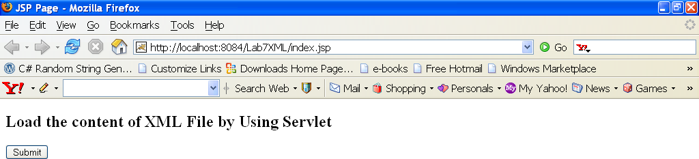
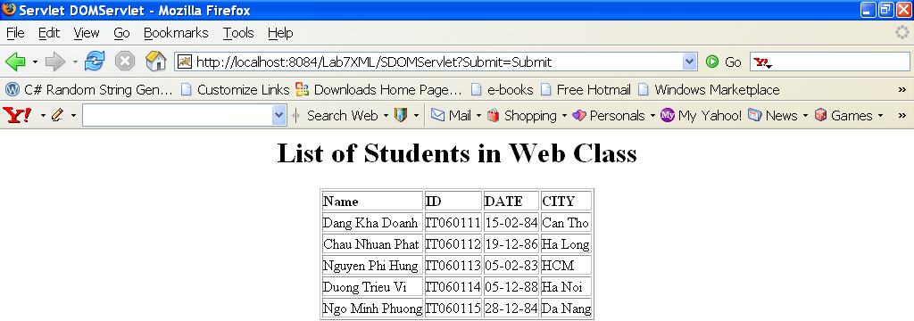
Exercise 4: Base on the source code of Exercise 3, you create a Servlet to get the content of book.xml (from Exercise 1)

This is the result:
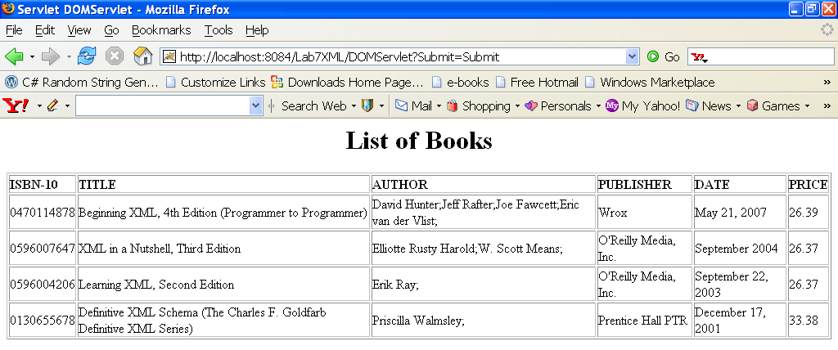
- Simple API for XML (SAX)
  - SAX is an alternate method for parsing XML documents that uses an event-based model - notifications called events are raised as the document is parsed.
  - With this event-based model, no tree structure is created by the SAX-based parser to store the XML document’s data - data is passed to the application from the XML document as it is found.
  - The SAX parser invokes certain methods when events occur. The following specifies some methods called upon events occurs (see API for more details)
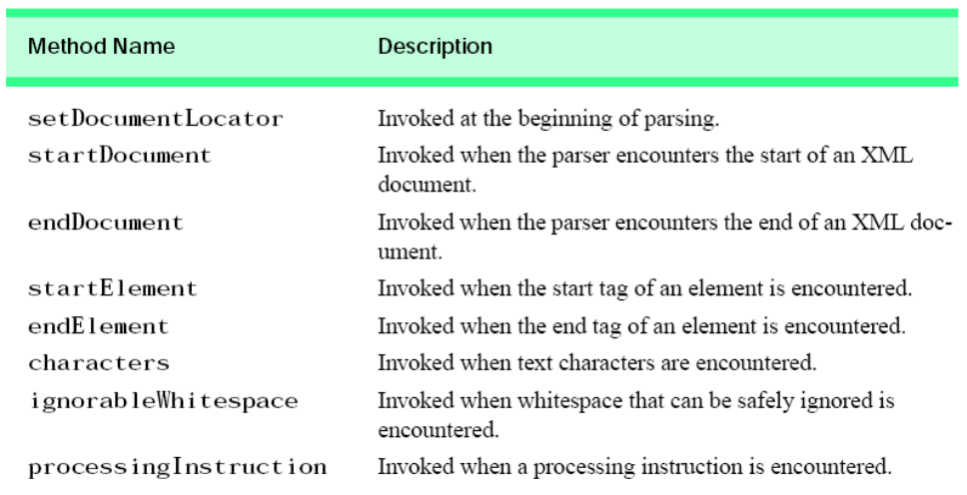
Given the following XML file:
<?xml version="1.0" encoding="UTF-8"?>
<RootElement param="value">
<FirstElement>
Some Text
</FirstElement>
<SecondElement param2="something">
Pre-Text <Inline>Inlined text</Inline> Post-text.
</SecondElement>
</RootElement>

This XML document, when passed through a SAX parser, will generate a sequence of events like the following:
XML Processing Instruction, named xml, with attributes version equal to "1.0" and encoding equal to "UTF-8"
XML Element start, named RootElement, with an attribute param equal to "value"
XML Element start, named FirstElement
XML Text node, with data equal to "Some Text" (note: text processing, with regard to spaces, can be changed)
XML Element end, named FirstElement
XML Element start, named SecondElement, with an attribute param2 equal to "something"
XML Text node, with data equal to "Pre-Text"
XML Element start, named Inline
XML Text node, with data equal to "Inlined text"
XML Element end, named Inline
XML Text node, with data equal to "Post-text."
XML Element end, named SecondElement
XML Element end, named RootElement

  - Steps for SAX Parsing:
    - Tell the system which parser you want to use.
    - Create a parser instance.
    - Create a content handler to respond to parsing events.
    - Invoke the parser with the designated content handler and document.
  - Exercise 5: copy source below to test how to get XML file using SAX
import java.io.*;
import org.xml.sax.*;
import javax.xml.parsers.SAXParserFactory;
import javax.xml.parsers.ParserConfigurationException;
import javax.xml.parsers.SAXParser;

public class BooksLibrary extends HandlerBase {
protected static final String XML_FILE_NAME = "src//WebClass.xml";
public static void main(String argv[]) {
// Use the default (non-validating) parser
SAXParserFactory factory = SAXParserFactory.newInstance();
try {
// Set up output stream
out = new OutputStreamWriter(System.out, "UTF8");
// Parse the input
SAXParser saxParser = factory.newSAXParser();
saxParser.parse(new File(XML_FILE_NAME), new BooksLibrary());
} catch (Throwable t) {
t.printStackTrace();
}
System.exit(0);
}
static private Writer out;

//===========================================================
// Methods in SAX DocumentHandler
//===========================================================
public void startDocument()
throws SAXException {
showData("<?xml version='1.0' encoding='UTF-8'?>");
newLine();
}

public void endDocument()
throws SAXException {
try {
newLine();
out.flush();
} catch (IOException e) {
throw new SAXException("I/O error", e);
}
}

public void startElement(String name, AttributeList attrs)
throws SAXException {
showData("<" + name);
if (attrs != null) {
for (int i = 0; i < attrs.getLength(); i++) {
showData(" ");
showData(attrs.getName(i) + "=\"" + attrs.getValue(i) + "\"");
}
}
showData(">");
}

public void endElement(String name)
throws SAXException {
showData("</" + name + ">");
}

public void characters(char buf[], int offset, int len)
throws SAXException {
String s = new String(buf, offset, len);
showData(s);
}

private void showData(String s)
throws SAXException {
try {
out.write(s);
out.flush();
} catch (IOException e) {
throw new SAXException("I/O error", e);
}
}

// Start a new line
private void newLine()
throws SAXException {
String lineEnd = System.getProperty("line.separator");
try {
out.write(lineEnd);
} catch (IOException e) {
throw new SAXException("I/O error", e);
}
}
}
This is the result:
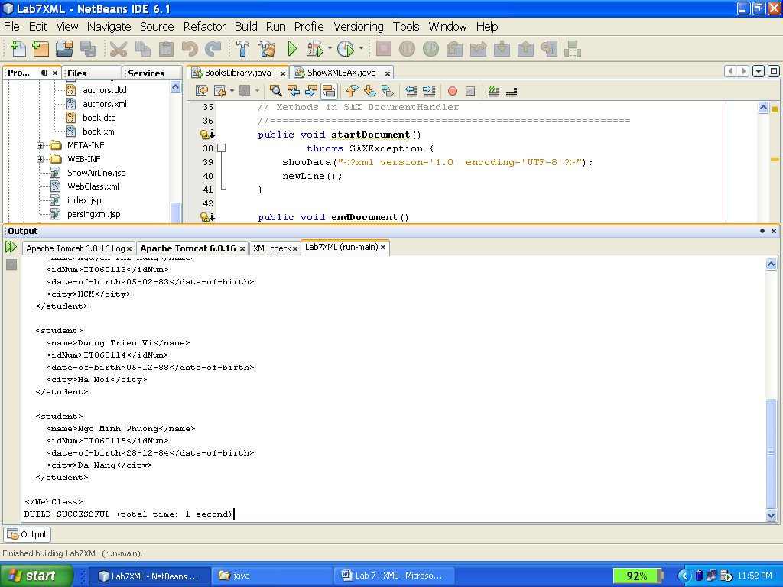
Part 3: Transforming XML
- What is XSLT?
  - XSLT (Extensible Stylesheet Language Transformations) is a language for transforming XML documents into HTML, XML, or other document formats.

  - XSL (Extensible Stylesheet Language) is a language for expressing stylesheets, specifies how to transform XML into HTML, XML, or other document formats. Use:
    - XPath to identify parts of an XML document
    - XSLT templates to apply transformations

  - XPath is an expression language used by XSLT to:
    - Locate elements and/or attributes within an XML document.
    - Test Boolean conditions
    - Manipulate strings
    - Perform numerical calculations
    - Ex:
<xsl:template match="/name/first" >
...
</xsl:template>

  - XSLT Stylesheet Elements
    - Matching and selection templates:
      - xsl:template match="xpath"
        - Defines a template rule for producing output
        - Applied only to nodes which match the pattern
        - Invoked by using <xsl:apply-templates>
      - xsl:apply-templates
        - Applies matching templates to the children of the
context node
      - xsl:value-of
        - Evaluates the expression as a string and sends the result to the output
        - Applied only to the first match
        - ". " selects the text value of the current node
Ex:
<xsl:template match="/">
<html>
<head><title>Ktee Siamese</title></head>
<body>
<xsl:apply-templates/>
</body>
</html>
</xsl:template>

<xsl:template match="name">
<h2><xsl:value-of select="."/></h2>
</xsl:template>

    - Branching elements
      - xsl:for-each select="expression"
        - Processes each node selected by the XPath expression
      - xsl:if
        - Evaluates Select any number of alternatives the expression to a boolean and if true, applies the template body
      - xsl:choose
        - Select any number of alternatives
      - xsl:output
        - Controls the format of the stylesheet output
        - Useful attributes:
method= "[html|xml|text]"
indent="[yes|no]"
version="version"
doctype-public="specification"
encoding="encoding"
standalone="[yes|no]"

  - Steps for Translating a Document
    - 1. Tell the system which parser to use
    - 2. Establish a factory in which to create transformations
    - 3. Create a transformer for a particular style sheet
    - 4. Invoke the transformer to process the document
  - Exercise 6: (refer 23.6)
    - Write XSL document to transform the book.xml XML document to HTML.
    - Use XSLT Example under the Code folder to check above documents.
    - Run XsltExample.java file, the results will be shown like below: (refer from chapter 23.7 XSLT Example 1: XSLT Document Editor – Textbook Core Web Programming, Second Edition)
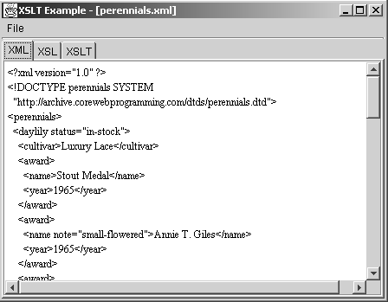
Figure 1: Presentation of XML tabbed pane in XsltExample with perennials.xml loaded

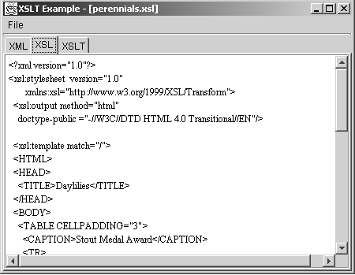
Figure 2: Presentation of XSL tabbed pane in XsltExample with perennials.xsl loaded

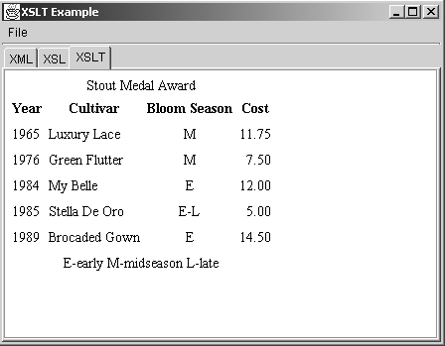
Figure 3: Result of XSLT transformation of perennials.xml and perennials.xsl

Additional exercise (bonus):
Write a JSP file to get information in XML file as Exercise 1, and export the output is as an excel file.

